ECON6217 Name ________Manning Worthley____

Homework #4

Differences in Differences

Answer the following questions as completely as possible. You can use this file and email it to me or use your own paper. You can cooperate with each other, but each student must turn in their own copy of the homework. This homework is due April 16, 2018.

1. Read the accompanying paper “The reality of reality television: Does reality TV influence local crime rates.” Briefly describe the research question and why the authors elect to use differences-in-differences.

The authors are interested in the effect of the reality show, Laguna Beach: The real orange county, and its popularity on the crime rates in that city. They elect to use the difference-in-difference method because they have a control group in the neighboring city, Dana Point and they want to measure the impact from the notoriety from the show on the local area crime.

1. Using the data laguna-replicate.dta (generously shared by Lesley Chiou) replicate Figure 1 using total crimes per capita (burglary, robbery, rape, auto theft, and larceny). Does the common trends assumption appear valid?

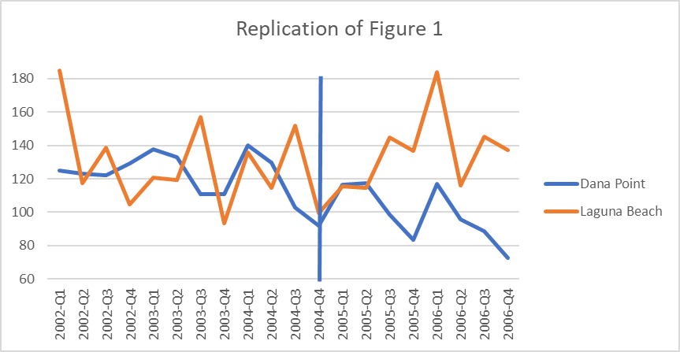

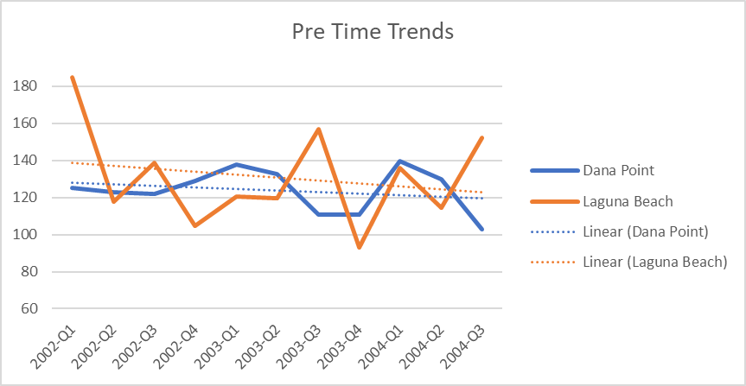

Plotting a linear trend for the pre-2004 Q3 period, it seems clear that there were common trends in the data in the pre-period through their very similar trend lines which suggests that the assumption is validated.

1. Replicate the lower panel of Table 1. Describe the differences in differences between Dana Point and Laguna Beach.

*Replication of Table 1:*



1. Generate a 2x2 matrix of differences for residential burglaries in Dana Point and Laguna Beach including difference-in-differences. How does the diff-in-diff result compare to the naïve analysis of pre-post comparison within Laguna Beach or post-post comparison between Dana Point and Laguna Beach
2. Replicate Table 2 adding a final row that reports the F-test of overall significance.